TECHNICAL SPECIFICATION
FABRIC-BACKED VINYL WALLCOVERING
______________________________________________________________

Product Acappella

Description Commercial quality vinyl wallcovering laminated onto a polycotton
osnaburg backing.

Weight 450 grammes per square metre.

Roll Size 137cm x 27m

Fire Rating Euroclass C / Class 0 and 1 to BS476 part 6 and 7

Adhesive Generally Tekfix Plus, though depends on substrate. Tekfix VOV should be used when installing around right angled corners.

Hanging Care should be taken during installation in order to produce optimum results. Apply adhesive to wall surface. Carefully smooth wallcovering onto wall surface using a spatula, allowing 5-10cm at top and bottom for trimming. Overlap lengths, and double cut through. Run seam roller up join to ensure even adhesion. Remove any adhesive seepage immediately with detergent solution and clean water. Rinse thoroughly. Reverse alternate lengths. Acappella has a random match.

Maintenance Fabric-backed vinyls offer an easy-clean finish, and high resistance to knocks and scrapes. They are designed to withstand high traffic levels, and will not tear easily. With regular cleaning they will retain their original appearance for many years depending on area of use.

Always carry out a trial in an inconspicuous area first, to ensure cleaning agent suitable. Clean with a mild non-soapy detergent with soft cloth, sponge or soft bristle brush to prevent build up of dirt and staining. Avoid polishes and abrasive cleaning agents as they will cause build up of dirt in the surface texture, and can also damage metallic finishes. Avoid strong active solvent cleaners as they can stain and damage the vinyl surface. Always clean from the skirting level upwards. Rinse thoroughly with clean water. Individual stains should be removed as quickly as possible. This wallcovering contains antimicrobials which guard against mildew and bacterial growth.

Health & Safety This product is classified as non-hazardous and therefore does not require any special handling. This product does not require special labelling.

Handling/Storage Store at ambient temperatures away from heat source. Suitable lifting equipment may be required.

Fire Fighting Any extinguishing media are suitable. Wear self contained breathing apparatus, protective clothing and full face mask. Fumes should be ventilated immediately due to possible liberation of noxious gases.

Ecological This product is not bio-degradable. Dispose of in accordance with Local Authority regulations or via an authorised contractor.

__________________________________________________________________________________
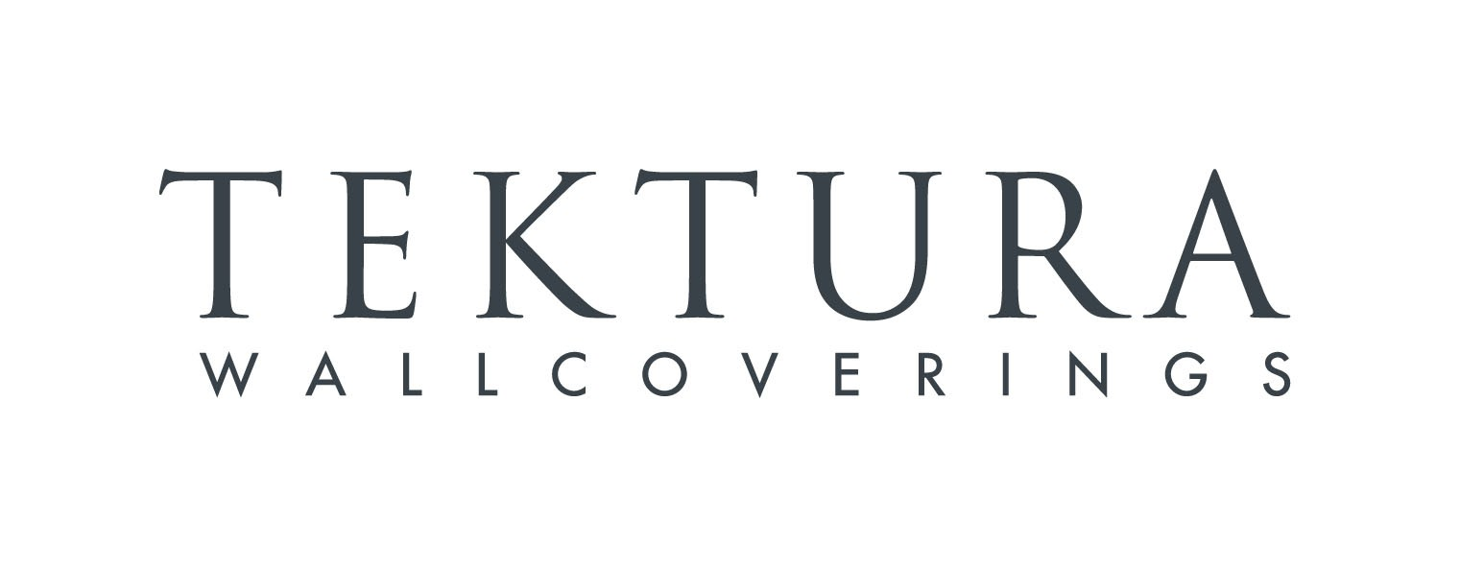
TEKTURA PLC, Suite 1.03 Harbour Island, 34 Harbour Exchange Square, London E14 9GE
Tel 020 7536 3300 Fax 020 7536 3322

